Name_________________________________________________ Date________________ Class___________
Exploration Changes the World
Instructions: Exame the diagram. Read the Background. Answer the questions.
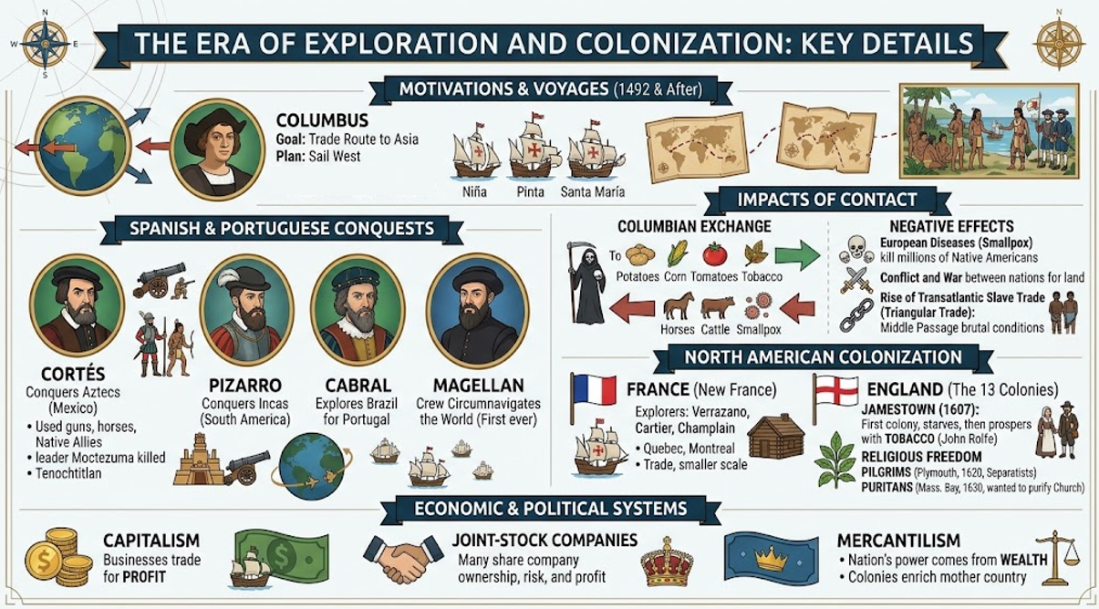
Background: The Age of Exploration started in 1492 when Christopher Columbus sailed west for Asia but landed in the Americas instead. Spanish and Portuguese explorers soon claimed vast lands. Cortés conquered the Aztecs, Pizarro defeated the Incas, Cabral claimed Brazil, and Magellan’s crew circumnavigated the globe. While these voyages created the global Columbian Exchange of crops and animals, they also caused terrible tragedy through smallpox epidemics, European land wars, and the brutal Transatlantic slave trade. Later, France and England built settlements across North America, including Quebec, Jamestown, and New England. These expanding empires were driven by new economic systems like joint-stock companies and wealth-focused mercantilism.
1. Who were some significant individuals that impacted exploration? Describe their impact.

2. What were some positive and negative impacts that came from these pursuits in exploration?

3. What were some specific economic impacts that came about during this age of exploration?

4. Create your own open-ended question on ANYTHING above.

Answers:
1. Who were some significant individuals that impacted exploration? Describe their impact.
Christopher Example: Columbus reached the Americas while looking for a route to Asia, and Hernán Cortés conquered the Aztec Empire for Spain. Additionally, Ferdinand Magellan’s crew completed the first voyage around the world, and Pedro Álvares Cabral claimed Brazil for Portugal.
2. What were some positive and negative impacts that came from these pursuits in exploration?
A major positive impact was the Columbian Exchange, which allowed useful new crops, animals, and goods to be traded globally. However, negative impacts included the spread of deadly European diseases like smallpox that killed millions of Native Americans, as well as the rise of the brutal Transatlantic slave trade.
3. What were some specific economic impacts that came about during this age of exploration?
Exploration boosted capitalism and mercantilism, where nations focused on building wealth by controlling colonial trade and resources. Joint-stock companies also developed, allowing investors to buy shares in trading businesses to split both the financial risks and profits.
4. Create your own open-ended question on ANYTHING above.
Answers will vary from student to student.

