Name_____________________________________________ Date__________________ Class_____________
Absolute and Constitutional Monarchs
Instructions: Review the chart. Read the Background. Answer the questions.
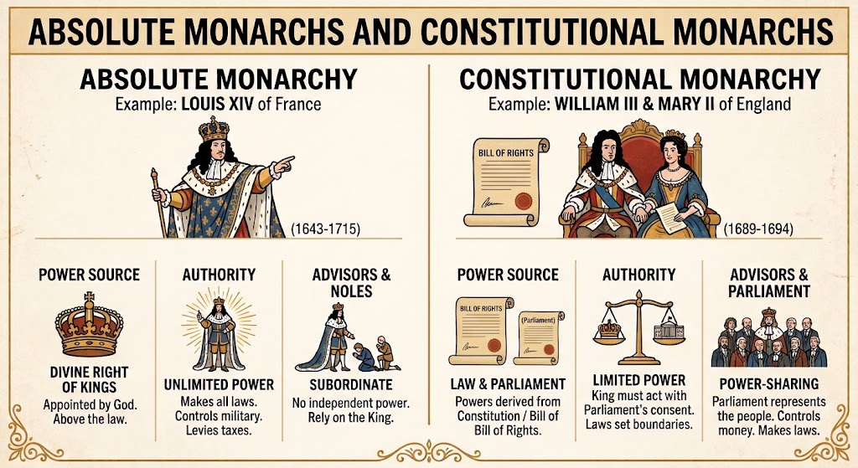
Background: An absolute monarch holds complete, total power over their country and operates above the law. They believe their authority comes directly from God, a concept known as the Divine Right of Kings. King Louis XIV of France was a famous absolute ruler who made all laws, set taxes, and controlled the military without needing anyone's permission. In contrast, a constitutional monarch shares power with a governing body like Parliament. Under this system, the King and/or Queen must follow set laws and a written Constitution or Bill of Rights. William III and Mary II of England ruled this way after accepting the English Bill of Rights in 1689. Their power was limited because Parliament represented the people, controlled the country's money, and passed the laws. Members of Parliament represented smaller areas in Britain and had to answer to the people of their area. Ultimately, the biggest difference is that absolute monarchs answer to no one, while constitutional monarchs must follow the law and share power.
1. How does an Absolute Monarch function? Explain.

2. How does a Constitutional Monarch function? Explain.

3. Which system do you think would be more likely to provide the most rights for citizens? Elaborate and explain your answer.

4. Create your own open-ended question on ANYTHING from the chart and text above.

Answers:
1. How does an Absolute Monarch function? Explain.
The ruler has essentially unlimited power. They create the rules and execute the plans of the government.

2. How does a Constitutional Monarch function? Explain.
The monarch has power, but must share it with another group, like parliament. Therefore, there are limits to the monarch’s power.

3. Which system do you think would be more likely to provide the most rights for citizens? Elaborate and explain your answer.
Constitutional Monarchs would have limited power and people would be able to influence the other leaders like Parliament. Therefore, this system would more likely give more rights to citizens. Absolute Monarchs could challenge anyone’s rights and have no check on their power.

4. Create your own open-ended question on ANYTHING from the chart and text above.

Answers will vary based on student responses.

