Name_________________________________________________________ Date_______________ Class____________
Louis the 14th: The Sun King of France
Instructions: Read the chart and the background. Answer the questions.
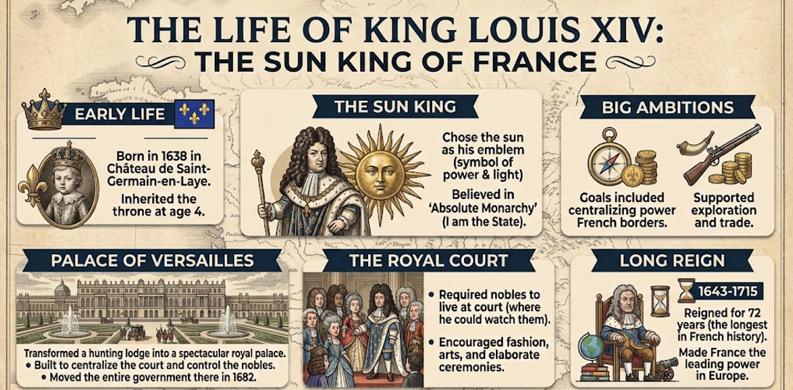
Background: King Louis XIV (1638-1715), known as the "Sun King," was born in 1638 and inherited the French throne at just four years old, eventually growing up to become one of Europe's most powerful absolute monarchs. Because he was too young to rule initially, the country was managed by advisors during his childhood, but he took full control of the government in 1661 with his famous belief that "I am the state." He famously chose the sun as his personal emblem to symbolize that he was the center of the nation, claiming he brought “light” and order to France. To display his immense power and keep a close eye on his nobles, he built the dazzling and extravagant Palace of Versailles, moving the entire royal court there in 1682. He figured if he created a lavish lifestyle for royal nobles, and they realized their lifestyle was dependent on him, they would never want to rise against him so that they could continue enjoying the riches and entertainment he gave them. He transformed France into a cultural and military superpower. However, his luxurious lifestyle, grand palace upkeep, and numerous expensive wars drained the national treasury and heavily taxed the common people, planting the seeds for future economic crisis. He also revoked religious freedom for French Protestants, known as Huguenots, causing hundreds of thousands of skilled workers to flee the country. When he died in 1715, he left behind a brilliantly shining legacy of arts and culture, but also a deeply indebted nation that would struggle for generations to come.
1. What was Louis the 14th trying to communicate by choosing the sun as his personal symbol?

2. Why did Louis the 14th make the nobles move to the Palace of Versailles? What was his goal?

3. What impact and legacy did Louis the 14th leave for France after he died? How was France different because of his leadership?

4. Make your own open-ended question on ANYTHING from the items above. Have a partner answer your question.

- - - - - - - - - - - - - - - - - - - - - - - - - - - - - - - - - - - - - - - - - - - - - - - - - - - - - - - - - - - - - - - - - - - - - - - - - - - - - - - - - - -

Answers:
1. What was Louis the 14th trying to communicate by choosing the sun as his personal symbol?
He was showing he wanted absolute power and wanted to be the absolute focal point of society. He thought he brought “light” and order to French society.

2. Why did Louis the 14th make the nobles move to the Palace of Versailles? What was his goal?
He wanted to control them. He figured if their lifestyle depended on him they would be loyal to him.

3. What impact and legacy did Louis the 14th leave for France after he died? How was France different because of his leadership?
Louis had a huge impact on arts and entertainment. He also funded exploration and other efforts. Yet, he left a legacy of financial debt as a hardship for the French people.

4. Make your own open-ended question on ANYTHING from the items above. Have a partner answer your question.
Student answers will vary.
- - - - - - - - - - - - - - - - - - - - - - - - - - - - - - - - - - - - - - - - - - - - - - - - - - - - - - - - - - - - - - - - - - - - - - - - - - - - - - - - - - -

