Name_____________________________________________ Date___________________ Class____________
Feudalism in Europe and Japan
Instructions: Examine the picture. Read the Background. Answer the questions.
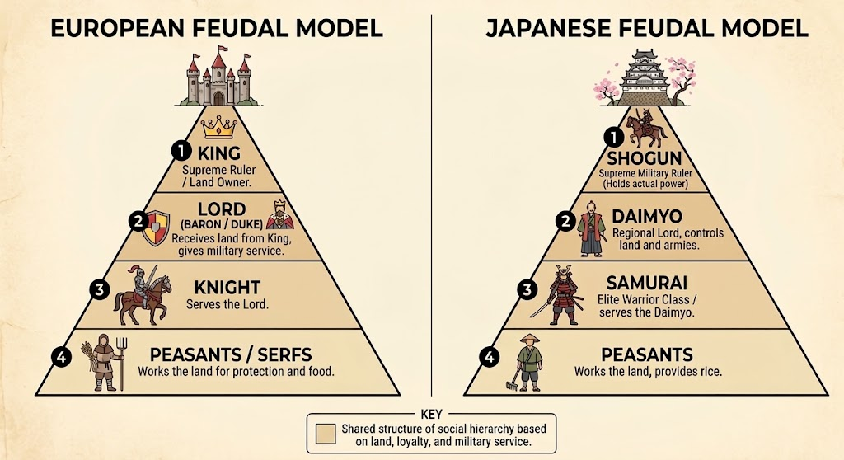
Background: In a way that was very similar to European feudalism, feudal Japan was built around land, loyalty, and powerful military leaders. In Japan, regional lords called Daimyōs ruled territories, built castles, and commanded armies. Above them was the Shogun, a supreme military dictator who held actual power over the Emperor. Notable historical leaders included shoguns like Minamoto no Yoritomo (1147-1199 CE) and Tokugawa Ieyasu (1543-1616 CE), as well as powerful Daimyōs like Oda Nobunaga (1534-1582). European feudalism lasted roughly from 500 CE to 1500 CE, while Japanese feudalism spanned from around 1185 CE to 1868 CE. In both regions, peasant farmers worked the land under the protection of wealthy landowning lords. While European Lords depended on Knights for defense, Japanese Daimyōs relied on loyal Samurai Warriors.
1. Explain the purpose of these two terms: Samurai and Peasants.

2. What do we learn about EACH of these cultures that they needed the service of Knights in Europe and Samauri in Japan?

3. Why do you think the Lords agreed to serve the King in the European arrangement? What did they get out of it?

4. Create an open-ended question on ANYTHING from the items above that a student may be thinking about. Write your question on the dotted line. Once done, have another student answer your question BELOW the dotted line or simply discuss your question with the other student.

- - - - - - - - - - - - - - - - - - - - - - - - - - - - - - - - - - - - - - - - - - - - - - - - - - - - - - - - - - - - - - - - - - - - - - - - - - - - - - - - - - -

Answers:
1. Explain the purpose of these two terms: Samurai and Peasants.
Samurai: Warriors in feudal Japan who served the Daimyo Lords.

Peasants: The bottom sections of the class system in both systems who helped provide food.

2. What do we learn about EACH of these cultures that they needed the service of Knights in Europe and Samauri in Japan?

The Lords and Daimyo each realized violence could occur in their areas. They needed military protection.

3. Why do you think the Lords agreed to serve the King in the European arrangement? What did they get out of it?
The Lord’s only had power because the King gave it to them. There power was in the land they owned. Since they go land from the King, they could afford to hire Knights for protection and profit off the work of peasants.

4. Create an open-ended question on ANYTHING from the items above that a student may be thinking about. Write your question on the dotted line. Once done, have another student answer your question BELOW the dotted line or simply discuss your question with the other student.

Answers will vary based on the questions the student wants to ask.
- - - - - - - - - - - - - - - - - - - - - - - - - - - - - - - - - - - - - - - - - - - - - - - - - - - - - - - - - - - - - - - - - - - - - - - - - - - - - - - - - - -

