Name___________________________________________ Date_________________ Class______________
The Impact of Machiavelli
Instructions: Read the background and answer the questions.
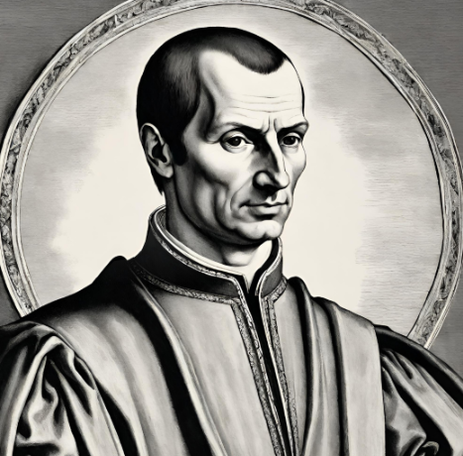
Background: During the Renaissance (1300-1600 CE), many thinkers believed leaders should be kind, honest, and focus on helping people. They claimed leaders were bound to be moral toward those they led and it would be ethically wrong to act otherwise. Niccolò Machiavelli (1469-1527 CE) completely flipped that idea upside down in his 1513 book The Prince. He argued that a ruler's main job isn't to be nice, but to stay in power and keep the country safe, even if it means lying, breaking promises, or being cruel. Machiavelli famously said it is much safer for a leader to be feared than to be loved, believing this harsh approach was just the reality of how power actually works instead of how people wish it worked. To prove his point, he pointed to the ancient general Hannibal (247-181 BCE), who, while ruling the army of the empire of Carthage, led a massive army made of soldiers from many different countries to attack Rome. Machiavelli argued that Hannibal's troops never turned on each other strictly because Hannibal was so harsh and terrifying that no one dared to disobey him. Hannibal’s approach was cruel and harsh, but it was effective in achieving his goal of attacking Rome. If ruthlessness helped a leader achieve his or her goals, Machiavelli felt that the tactic was worth it.
1. How did many in the Renaissance culture believe a leader should act?

2. How was Machiavelli’s view of leadership different from many in the Renaissance?

3. How did Machiavelli view Hannibal’s impact on history? Explain

4. How do you think Machiavelli tried to justify his harsh view of leadership? How do you think his critics responded to such justifications?

Answers:
1. How did many in the Renaissance culture believe a leader should act?
They felt leaders just be kind of just to the people they ruled.

2. How was Machiavelli’s view of leadership different from many in the Renaissance?
He felt leaders should be ruthless and harsh.

3. How did Machiavelli view Hannibal’s impact on history? Explain
Hannibal was able to achieve his goal of attacking Rome; therefore, his tactics justified reaching his goals.

4. How do you think Machiavelli tried to justify his harsh view of leadership? How do you think his critics responded to such justifications?
Machiavelli would assert that, if your ruthlessness helped you achieve your goals, it was justified. His critics probably appealed to morality and other concepts to claim that such approaches were immoral

