Name______________________________________________________ Date________________ Class________________

Word Search: Survey of the USA 1776 - 1900
Instructions: (Part A), find all the terms in the word search below. (Part B), on the back, you pick any ten terms you want from the word search list and write one complete sentence explaining the historical significance of each term. Use the content reading guide below this word search worksheet to find information for your explanation.
Part (A)


ABOLITIONISM  ALASKA  BRITAIN  CALIFORNIA  CIVIL WAR  CONSTITUTION  EMANCIPATION  EXECUTIVE  FACTORIES  FORT SUMTER  GHENT  GUAM  HAWAII | IMMIGRATION  IMPRESSMENT  JACKSON  JEFFERSON  JUDICIAL  LEGISLATIVE  LINCOLN  LOUISIANA  MANIFEST DESTINY  MEXICO  NAPOLEON  NATIVE AMERICANS  PARIS | PHILIPPINES  PUERTO  RAILROADS  RECONSTRUCTION  RICO  SECEDED  SEGREGATION  SOUTH CAROLINA  TAXATION  TEXAS  TRAIL OF TEARS  WASHINGTON

Part B: Now, you pick any ten terms you want from the word search list and write one complete sentence explaining the historical significance of each term.
1.

2.

3.

4.

5.

6.

7.

8.

9.

10.

Reading Guide: Survey of the USA: 1776-1900
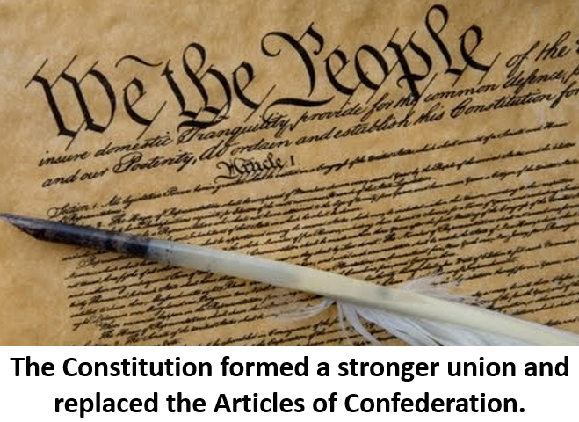
In 1776, due to agitation toward taxation without representation and other issues, the 13 Colonies of Britain became the USA and officially declared their independence from Britain. In 1783, by signing the Treaty of Paris, Britain acknowledged that the USA had won the American Revolutionary War and granted them independence. When America first started, they were governed by the Articles of Confederation, which was ratified in 1781.

Many asserted the Articles of Confederation were too weak because the system had no way to raise federal money and created a government where it was difficult to get anything accomplished. The USA then removed the Articles of Confederation and implemented the Constitution, in 1789. The Constitution created three branches of government, the legislative, judicial, and executive branches. Likewise, with the 10 Amendments, the Constitution gave citizens individual rights in the Bill of Rights. George Washington (1732-1799) served as the first President, which is the head of the executive branch.

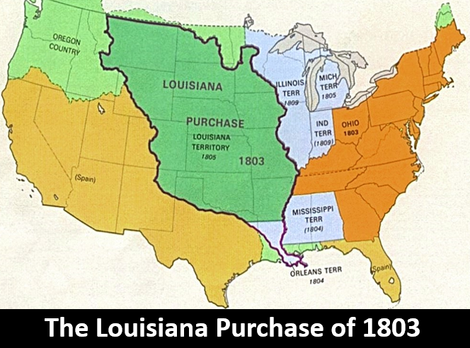
President Thomas Jefferson (1743-1826) bought a massive amount of land from France, then led by Napoleon (1769-1821), in 1803. The purchase was called the Louisiana Purchase. By the 1840s, through other acquisitions from Spain, Britain, and Mexico, the USA stretched all the way to the Pacific Ocean. During the 1800s, many held to the belief of Manifest Destiny, the religious belief that God wanted the USA to stretch across the continent. America and Britain went to war again from 1812 to 1815. The dispute was largely about naval disputes on the seas. One practice that caused tension was impressment. In this practice, Britain would take American ships and put them in the British navy. This was partially to build their navy in their fight against Napoleon in France. Britain even invaded the USA, but America was able to maintain their sovereignty and stop the British invasion. The Treaty of Ghent ended the conflict in 1815.

From the 1600s to the late 1800s, Britain and then the USA had military engagements with Native Americans. The Indian Removal Act of 1830 forced Native American groups in the South to move west. Many died during this transition. The route came to be known as the Trail of Tears due to the persecution and death that came from the removal. The transition was supported by President Andrew Jackson (1767-1845), despite the horrific occurrences that it brought about.

The 13 Colonies of England broke away in 1776 and became the USA. In a similar way, Mexico gained its independence from Spain in 1821. Many Americans settled in Texas in the early to mid-1800s. Yet, Mexico owned Texas. Americans in Texas revolted and gained their independence from Mexico in 1836. In 1845, Texas joined the USA and wanted expansion. Mexico was furious and went to war with the USA. The USA won the Mexican American War (1846-1848), which solidified the USA’s claim on many western regions of North America, like California.
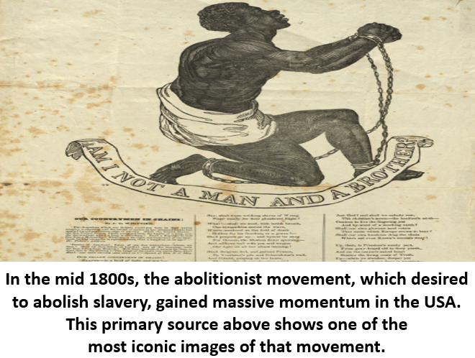
By the mid-1800s, the USA was becoming torn on the issues of slavery. Many in the South wanted slavery to continue due to their agricultural economy rooted in farming. Yet, a massive movement to end slavery arose, called abolitionism. Abraham Lincoln was elected in 1860. He represented the Republican Party, a party opposed to the expansion of slavery. When Lincoln was elected, pro-slavery South Carolina seceded from the USA and other Southern states followed. They formed the Confederate States of America.

Starting at Fort Sumter in South Carolina, the Northern Union of the USA went to war, refusing to let the Southern Confederacy leave the union. Lincoln did not come to office to end slavery, though he viewed the slave system as morally reprehensible and evil. He wanted, above all, to preserve the union of the USA. Yet, as the war progressed, Lincoln linked the ending of slavery with the North’s war aims. In 1863, Lincoln issued the Emancipation Proclamation, which freed all slaves in the Southern Confederacy. However, slaves in the neutral border states remained in slavery. After the South surrendered, in 1865, Congress passed the 13th Amendment, which ended all slavery in the USA. In the Civil War, over 600,000 Americans died. Lincoln himself was assassinated by John Wilkes Booth (1838-1865), a sympathizer of the South. Afterward, the USA tried to rebuild the South in the era of Reconstruction, lasting from 1865 to 1877.

Congress not only freed all slaves with the 13th Amendment, they also passed the 14th Amendment, guaranteeing equal rights to all Americans, including former slaves. The North kept a military presence in the South to enforce these amendments. Yet, by 1877, the troops left. Eventually, the Southern governments created segregation. This meant the South asserted they would give “separate, but equal” rights to African Americans. This created a system of injustice and racism that dominated the South into the early to mid-20th century.

Railroads were already being used to provide transportation across the USA before the Civil War. The Civil War increased the need for the North to use its industrial might to achieve victory. Due to this, the North radically increased their railroad usage. After the Civil War, the railroads helped spur on massive industrial pursuits and factories increased across the nation. As factories increased and railroads helped the spread of goods, a massive wave of immigration from Asia and from Europe grew the USA in the late 1800s and early 1900s, as people flocked to America seeking work.

In the late 1800s and early 1900s, the USA expanded its territory. In 1867, the USA purchased Alaska from Russia. In 1898, the USA gained Hawaii as a territory. Also, the USA and Spain went to war in 1898 when an American ship, the USS Maine, exploded near Cuba and Spain was blamed. After the USA won the Spanish American war of 1898, the USA gained Spain’s territories of the Philippines, Puerto Rico, and Guam.

