Name______________________________________________________ Date________________ Class________________

Word Search: Exploration and Colonization Begins
Instructions: (Part A), find all the terms in the word search below. (Part B), on the back, you pick any ten terms you want from the word search list and write one complete sentence explaining the historical significance of each term. Use the content reading guide below this word search worksheet to find information for your explanation.
Part (A):



AFRICA  ATLANTIC  BAHAMAS  BRITAIN  COLONIZATION  COLUMBUS  DIAS  DUTCH  EUROPE | GAMA  GYRES  IBERIAN  INDIANS  JAPAN  MUSLIMS  NETHERLANDS  NINA  PINTA | POPE  PORTUGAL  SAILING  SILK  SMALLPOX  SPAIN  SPICES  TAINO  TORDESILLAS

Part B: Now, you pick any ten terms you want from the word search list and write one complete sentence explaining the historical significance of each term.
1.

2.

3.

4.

5.

6.

7.

8.

9.

10.

Reading Guide:

European Exploration Begins

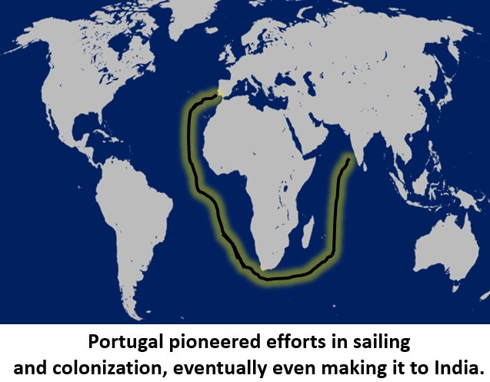
At the edge of the Iberian Peninsula, Portugal was in an ideal location for exploration, since they bordered the Atlantic Ocean. They practiced colonization, when a larger nation controls weaker areas around the world. Their innovations in sailing allowed them to control trade in West Africa. This permitted the nation to gain resources and goods outside their own realm and increase their wealth. These innovations in sailing eventually allowed Portugal to travel all the way to the Indian Ocean. This further connected the European world to the world of Asia. The riches that came with African exploration encouraged Portugal to pursue even further expeditions. A Portuguese sailor, Bartolomeu Dias (1450-1500), wanted to sail around Africa. The waters around the Southern tip of Africa are treacherous. Yet, Dias found a way to get through, the first European to do so. Due to rough weather, he headed for open sea. To his surprise, his ship was pushed back around the tip of Africa. The reason was that Dias had discovered ocean gyres, whirlpool like currents that work like rivers in the ocean.

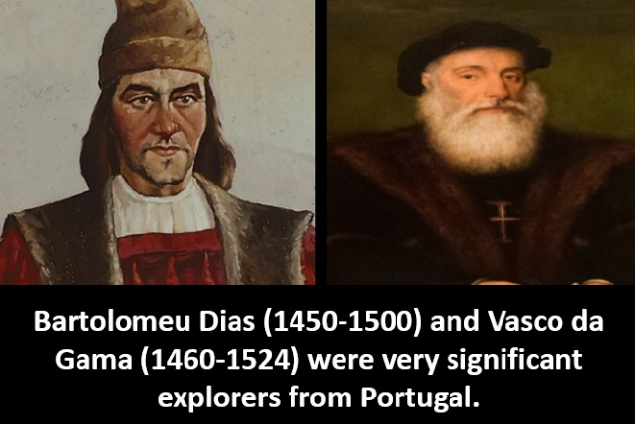
In 1488, the South Atlantic Gyre helped push Dias’ ship past the Southern tip of Africa, the Cape of Good Hope. Dias didn’t make it to India, he had to return and resupply. Yet, he proved it was possible to sail around Africa. Another Portuguese explorer, Vasco da Gama (1460-1524), did make to India and started a vital trade endeavor for the Portuguese in East Asia to gain spices and other resources.

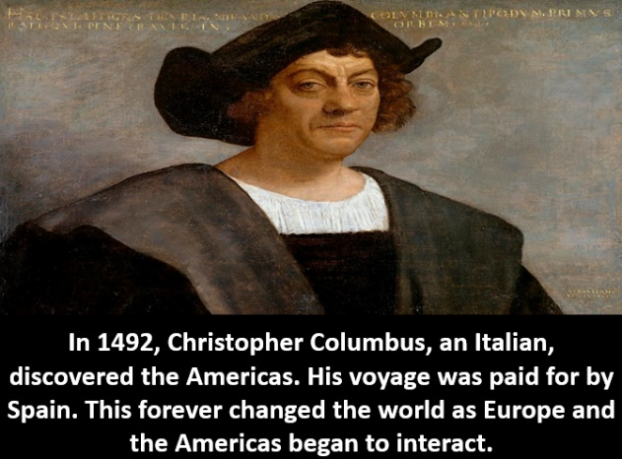
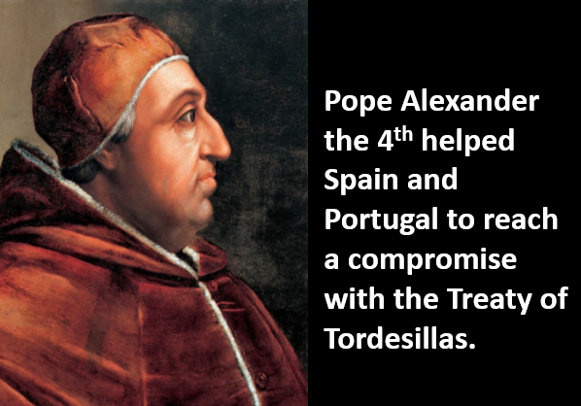
In 1492, Spain funded an Italian sailor, Christopher Columbus. Columbus wanted to sail to Asia. He theorized that he could sail west and eventually end up in Asia. When he reached the modern day Caribbean islands, he thought he was in East India. Yet, he had actually discovered the Americas for the Europeans. This was one of the most momentous events in history. For the first time, Europeans would start to colonize and explore the Americas due to this finding. Sponsored by Spain, Columbus’ ships, the Nina, Pinta, and Santa Maria, set sail to find a western route to Asia. Many people say Columbus set sail for India. India was not the country of today, it was a broad term for Asia. In the modern day Bahamas and Caribbean, Columbus encountered the Native American group known as the Taino. Thinking he was in Asia, he mistakenly called them Indians. This interaction forever changed the world. New trade, conflict, the spread of diseases such as smallpox, and other occurrences would come about for the centuries after this encounter.

Spain and Portugal were both rivals in terms of exploration and colonization. As they claimed various areas in the New World, this rivalry grew. Pope Alexander the 4th (1431-1503) feared that, without a compromise, these two nations would end up going to war. In 1494, Pope Alexander the 4th got Portugal and Spain to sign the Treaty of Tordesillas. Each nation recognized the boundaries set by the treaty to determine which area Spain would possess and which region Portugal would control in terms of colonization.

Trade in Asia was spurred on through spices, items that could keep food fresh, and other items, such as silk. Various Muslim groups had controlled this trade, before Portugal started bypassing their land routes through sailing. As the Portuguese gained more of the spice trade, conflict developed with the various Muslim groups. Through various military engagements with Muslim traders and natives of Asia, Portugal solidified its dominance in the spice trade in Asia and the trade of other items as well.

In the 1600s, the British and Dutch (from the Netherlands) also pursued exploration and colonization efforts. They too wanted to trade in the Indian Ocean. The Dutch and British also had conflict with one another. Britain established dominance in North America and the Dutch established control in East Asia. While they had a sizeable presence in East Asia, France and Britain also began to cultivate massive control in North America. Now, many countries in Europe were pursing exploration and colonization around the world.

.

