Name______________________________________________________ Date________________ Class________________

Word Search: The Reformation Part 2: Beyond Luther
Instructions: (Part A), find all the terms in the word search below. (Part B), on the back, you pick any ten terms you want from the word search list and write one complete sentence explaining the historical significance of each term. Use the content reading guide below this word search worksheet to find information for your explanation.

Part (A):



ANABAPTISTS  ANGLICAN  APOCRYPHA  BIBLE  BOLEYN  CALVIN  CATHERINE  EDWARD | ELIZABETH  GENEVA  HELWYS  HENRY  IGNATIUS  INQUISITION  KNOX  LUTHER  MARY | POPE  PREDESTINATION  PROTESTANTS  PURITANS  SMYTH  SWITZERLAND  THEOCRACY  TRENT  ZWINGLI

Part B: Now, you pick any ten terms you want from the word search list and write one complete sentence explaining the historical significance of each term.
1.

2.

3.

4.

5.

6.

7.

8.

9.

10.

Reading Guide: The Reformation Part 2: Beyond Luther
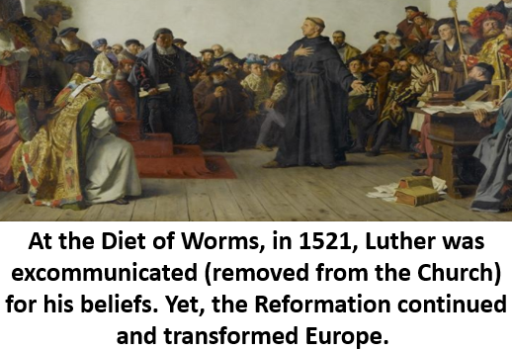
On October 31st, 1517, Martin Luther nailed the 95 Theses (95 Complaints) against the Catholic Church to a Church door in Germany. Historians mark this event as the start of the Reformation. Luther felt the Catholic Church had drifted away from the original teachings of Jesus. He particularly hated the selling of indulgences, certificates claiming to forgive sin. Eventually, Luther claimed the only way to follow the original teachings of Jesus meant that only the Bible could the final authority for Christians. These teachings not only challenged religious authority in Europe, they challenged the government systems in Europe rooted in Catholic practice. Those who supported the Reformation were called Protestants, because they protested the Catholic Church.
King Henry the 8th (1491-1547) of England initially hated Martin Luther and wrote against his Protestant teachings. Pope Leo the 10th (1475-1521) even called Henry the “Defender of the Faith” for his stance against Protestantism. Yet, Henry began to have an affair with Anne Boleyn (1501-1536) and wanted to divorce his wife, Catherine (1485-1536), something against Catholic teaching. Pope Leo the 10th refused to comply with the request. Catherine was also the sister to Emperor Charles the 5th of the Holy Roman Empire. The Pope didn’t want to upset him. Even though he didn’t sincerely believe in Protestant theology, outraged that the Catholic Church wouldn’t end his first marriage, King Henry the 8th broke the English church away from the Catholic Church and formed the Church of England. Henry claimed he himself, not the Pope, was the top leader of the new denomination.
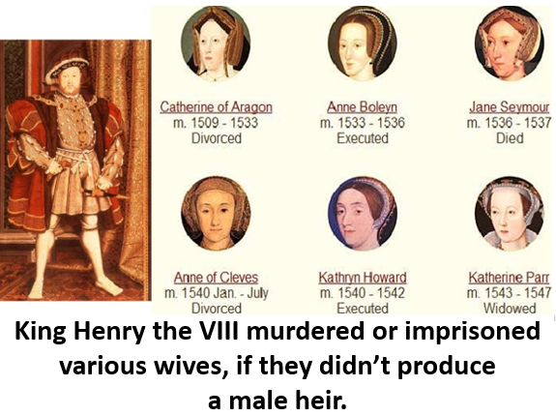
Henry called for Parliament to break England away from the Catholic Church. While he himself did not sincerely follow Protestant Theology, many in England did. Therefore, they gladly welcomed the Reformation to guide the new Church of England and implemented this path forward with a law called the Act of Supremacy in 1534. During his reign, Henry went on a furious spree of marrying various women and killing or imprisoning them, if they didn’t produce male heirs for him. A series of heirs descended from Henry as England struggled to solidify and implement its new, Protestant theological and religious system.
Henry’s son, Edward the 6th (1537-1553), was young and sick during his reign. Yet, his counsellors were committed Protestants and kept the Reformation going in England. Edward died at 16. After Edward’s death, his half sister, Mary the 1st (1516-1558), the daughter of Catherine, became Queen. She declared that England would be Catholic again. She executed many Protestants who challenged a return to Catholicism, this led to Protestants calling her “Bloody Mary.”
Mary died in 1558. When she passed away, many Protestant leaders saw it as a chance to once again remove Catholicism and allow Protestantism to reign in England. Elizabeth the 1st (1533-1603), Anne Boleyn’s daughter, took power. She heavily supported the Reformation and returned Protestantism to England. The Anglican Church was made official under Elizabeth. While this new church utilized Protestant theology, it practiced rituals and services that were very similar to Catholic methods of worship. Some liked this moderate approach, others, called the Puritans, wanted to see England “purified” from all practices similar to Catholicism.
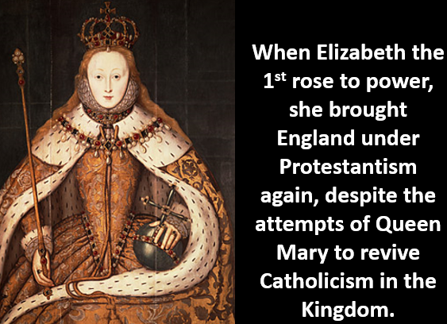
In Switzerland, Ulrich Zwingli (1484-1531) led his society to embrace the Protestant Reformation. Zwingli even met with Luther to discuss their commonalities. Yet, Luther felt their movements couldn’t be united as one entity because they had theological differences concerning the ritual of Christian communion and other dissimilarities. Protestants and Catholics literally fought battles against each other in Switzerland over their differences. Zwingli died in battle against Catholic factions in 1531.
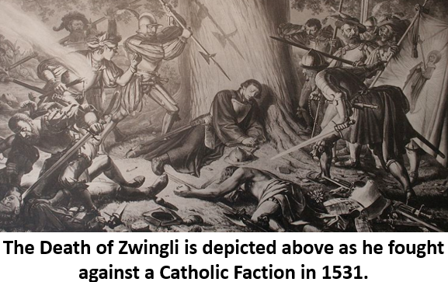
When French Catholics began to be violent toward Protestants, John Calvin (1509-1564) fled his country. He eventually settled in Geneva, Switzerland and led the area as a society guided by Protestant theology. Initially, Calvin faced hostility as a religious and government leader in Geneva. He even left for a time. Yet, he eventually solidified his leadership and paved the way for a Protestant society to take root in the region. Calvin was a prolific author. He created commentaries on many books of the Bible and wrote the Institutes of the Christian Religion to outline the teachings of his Protestant expression of faith. Calvin taught that all humans were naturally evil. They could be redeemed and forgiven by God through faith in Jesus Christ. He believed God had predestined who would be saved. Calvin felt God’s predestined elect would commit their lives to Jesus and follow him in this life. This is why the Protestant claim that faith alone could save was vital to Calvin. He believed the elect alone would express this faith authentically. Geneva was a strict theocracy, a government ruled by religious leaders. Geneva wasn’t the only place to practice Calvinism. John Knox (1513-1572) was inspired by the structure of Geneva and spread his teachings to Scotland. Those who followed Knox started the Presbyterian denomination. Calvinism spread to various other areas in Europe as well.
Martin Luther started the Protestant Reformation in 1517. Eventually, his followers were named Lutherans. Yet, those who followed Protestant theology were not a unified group. While they shared similar beliefs, such as faith alone in Jesus as necessary for salvation and the Bible alone as the final authority, they differed in other areas. After Luther’s movement began, various Protestant groups arose in Europe. In England, Anglicans held to Reformed theology. Yet, they were still very similar to Catholics in their expressions of worship. On the mainland of Europe, outside of the Lutherans, those who followed John Calvin were called Calvinists. Calvinists in Scotland started the Presbyterian denomination. Anabaptists also arose, led by men such as John Smyth (1570-1612) and Thomas Helwys (1575-1616). Unlike other Protestants, Anabaptists taught that professed believers alone should be baptized, not infants, since they believed baptism was merely a symbol for expressing one’s faith in Jesus, not an act that was necessary for salvation. They also taught the government should allow religious liberty for all and opposed theocracies.

While disagreeing with Luther’s claim that Catholicism had drifted from the original teachings of Jesus, the Catholic Church still did pursue changes that were reactionary to the Protestant Reformation. The Council of Trent met in various stages from 1545 to 1563 to develop and usher in these changes for Catholicism. They condemned many Protestant teachings as heretical, meaning they were against Christianity. Ignatius of Loyola (1491-1546), Pope Paul the 3rd (1468-1549), and Pope Paul the 4th (1476-1559) served as leaders for the movement. This movement reformed abuses in the selling of indulgences, while not outright banning them. They utilized a movement called the inquisition to punish heretics, claimed the added books of the apocrypha were Christian scripture, asserted the Bible had to be interpreted by Catholic leaders, not average Christians, and took other measures against Protestantism.

