Name____________________________________________________ Date_____________ Class__________

Instructions: Read the Background. Answer the questions
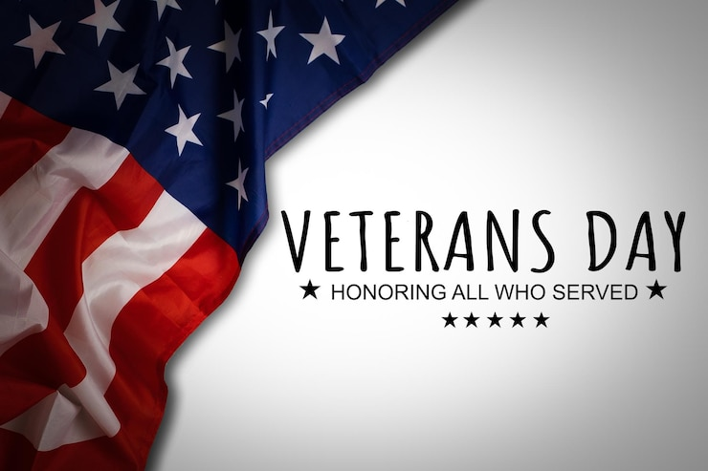
World War I, called “The Great War” back then, ended when the Treaty of Versailles was signed on June 28, 1919, in France. But the fighting had actually stopped earlier, on November 11, 1918, when an armistice (a temporary stop to fighting) between the Allied nations and Germany began. That’s why November 11 is remembered as the day World War I ended. In 1919, President Woodrow Wilson declared November 11 the first Armistice Day to honor those who fought and died in the war. People marked the day with parades, gatherings, and a pause in business at 11:00 a.m. In 1938, Congress made Armistice Day a national holiday to celebrate peace and honor World War I veterans.

After World War II and the Korean War, there were many more American veterans to honor. So, in 1954, Congress changed the name of the holiday from Armistice Day to Veterans Day to celebrate all U.S. veterans—from any war. President Dwight D. Eisenhower made the first Veterans Day proclamation that same year. Later, in 1968, a law was passed to move some holidays, including Veterans Day, to Mondays so workers could have three-day weekends. But this change caused confusion and wasn’t popular. So, in 1975, President Gerald Ford signed a law returning Veterans Day to its original date—November 11—starting in 1978. Today, Veterans Day is celebrated every year on November 11, no matter what day of the week it falls on. It is a day to honor and thank all American veterans for their bravery, love of country, and service to protect our freedom.

- What happened on November 11th, 1918?

- Why was Armistice Day changed to become Veterans Day?

- How did Gerald Ford impact how Veterans Day is celebrated today?
Answers:
- What happened on November 11th, 1918?
World War I ended with an armistice.

- Why was Armistice Day changed to become Veterans Day?
Now, there were Veterans of World War II and the Korean War. The country wanted to honor them as well.

- How did Gerald Ford impact how Veterans Day is celebrated today?
The day was changed to a Monday to give everyone a three day weekend. He changed it back to Nov. 11th so that the holiday would occur on its historic roots.

