Name______________________________________________________ Date________________ Class________________

**The Great Depression and Setting the Stage of WW II**

**Part 1: Crossword Puzzle: Instructions:** Use the clues below to complete the crossword puzzle, if you are writing with a pencil. If you are using a Google Classroom or online equivalent, just fill in the blanks of the clues.

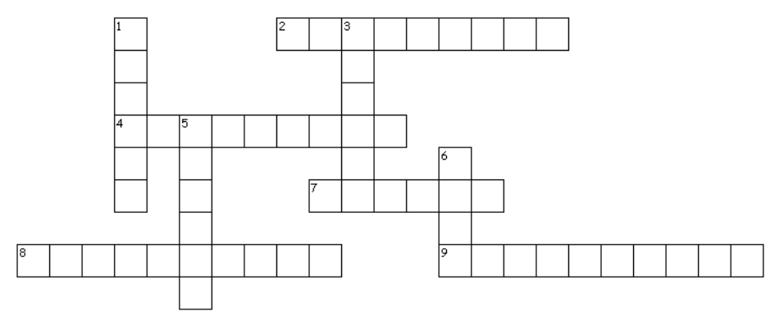

|  |  |
| --- | --- |
| Across:  2. _______________ is when money becomes weaker over time.  4. Benito _______________ set up a fascist government in Italy.  7. Herbert _________________was the Republican President of the USA, when the Great Depression began in 1929.  8. The Treaty of __________________ of 1920 officially ended WW I.  9. Hitler claimed Germany would never economically revive unless it gained _______________________, living space. | Down  1. The _________________ Republic lasted from 1918 to 1933.  3. Francisco _____________ emerged as the fascist dictator of Spain.  5. In the 1920 and 1940s, Joseph ______________ was ruling the Soviet Union as the Communist dictator.  6. FDR’s program actively to push back against the Great Depression was called the New _______________. |

**Part 2: Open Response: Instructions:** In at least one paragraph each, answer the questions below.

|  |  |  |  |
| --- | --- | --- | --- |
| 1. What was the purpose of the New Deal? Who created it? Why would some support it? Why would some oppose it? | | |  |
|  | 2. Describe some dictators that rose up on the eve of World War II. What countries were they from? How did their rise impact the people they ruled over? | | |
| 3. What economic problems did Germany face after World War I? How did the Weimer Republic try to address those problems? Were they successful? | |  | |

**The Great Depression and Setting the Stage of WW II**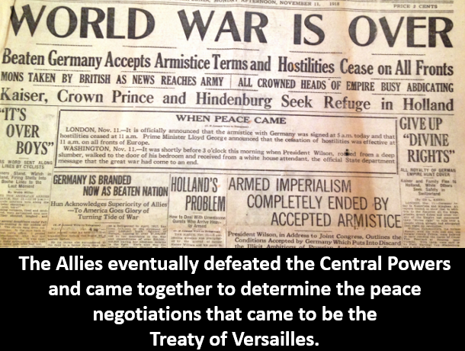

Many nations in Europe experienced millions of casualties in World War I. Likewise, they were left with the financial burdened of trying to rebuild. Numerous countries attempted democracy through coalition governments. This meant there were many political parties in various nations competing for power. No single party could achieve full control.

These diverse groups could seldom agree and often parted ways on various issues. This made government momentum toward addressing actual issues slow and burdensome.

The Weimar Republic lasted from 1918 to 1933. This was a German democracy that faced many problems after WW I. The Treaty of Versailles of 1920 officially ended WW I. All nations were trying to rebuild. Yet, Germany was given a “war guilt clause.” This meant Germany was forced to pay for war damages to the Allies. This caused their already struggling economy to struggle even more. Germany attempted to print large amounts of money to pump into their economy to give people more cash to spend and pay off debts. Yet, this made their economy worse. Inflation is when money becomes weaker over time. Printing massive amounts of currency sped up inflation and made the German currency, called the mark, very weak. Something as simple as bread would cost roughly one mark before WW I. After Germany printed massive amounts of money, bread cost over one hundred marks.

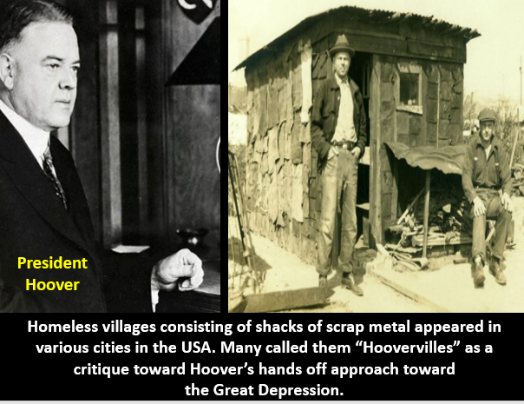The United States favored pretty well, after WW I. While they sent troops to the Allies, they avoided fighting in their own nation. Therefore, while European nations suffered, America’s economy seemed to be thriving. However, the prosperity would not last. Over a little more than a decade after WW I, the USA and the world entered into a horrible economic era called the Great Depression. Many farmers made profits shorty after WW I, since European markets needed outside agricultural goods due the devastation of WW I on their lands. Yet, by the late 1920s, these markets closed because Europeans were recovering. Many Americans were making meager salaries and could not contribute to the consumer economy of the USA in a meaningful manner. Many wanted to strike it rich in the stock market. In the stock market you can buy small portions of businesses, called stock, and reap money through selling the stock or receiving dividends, money from a businesses’ profits. Many Americans practiced “buying on margin.” This meant they would borrow money to buy stocks. If the stocks rose in value, they could pay back the loan. This was catastrophic for the American economy. Businesses were struggling, which meant stock holders lost money. On October 29, 1929, the Dow Jones Industry Average, which was a system measuring the stock value of 30 of the largest businesses in the USA, saw rapid drops in stock value. This was an indicator of an economic decline in the USA.

The stock holders could not pay back loans. In the midst of this, over farming helped contribute to a weather phenomenon called the Dust Bowl. Heat and wind sent dust around the nation further damaging crops. Farmers were not reaping profits and could not pay of their loans to banks either. This impacted banks closing. No one factor caused the depression. It was a vicious pattern of various occurrences that impacted the decline of the entire American economy. By the 1930s, unemployment had reached 25% in the USA. The ripple effect was harsh, European countries and other nations saw their economies crash too.

Herbert Hoover (1874-1964) was the Republican President of the USA, when the Great Depression began in 1929. He felt that a “hands off” approach was needed and that the economy was simply in a down business cycle and could recover. Yet, many Americans felt this passive approach was not working. Homeless people began building shacks for basic shelter. They dubbed these villages of homeless shacks “Hoovervilles.” Successfully challenging Hoover for the presidency in 1932 was a Democrat, Franklin Delano Roosevelt (1882-1945). FDR wanted the government to pay a more active role against the depression. For instance, since many people were out of work, he wanted to hire these people for government jobs. He also developed Social Security, a retirement pension system for America’s elderly. He hired millions of Americans to construct roads, build schools, and develop dams to produce electricity in regions. FDR felt investing in infrastructure would provide jobs for the present and create frameworks needed for the future.

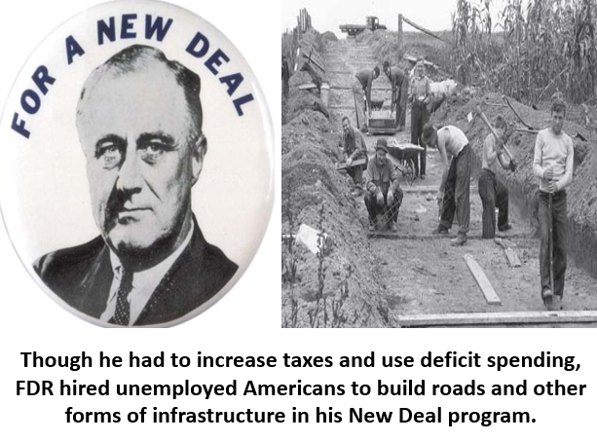FDR’s program actively to push back against the Great Depression was called the New Deal. It practiced deficit spending, which is when the government has to spend more than it has through borrowing. This required increasing taxes too. Supporters of the New Deal felt it helped alleviate some of the immediate pain many experienced in the Great Depression, such as joblessness. Critics of the New Deal argued it increased taxes, grew America’s debt, and only created temporary jobs, not lasting careers. They felt FDR was given too much power and that some of his actions as president violated his constitutional authority.

Denmark, Norway, and Sweden increased taxes and paid people to do government work and developed pensions for the elderly in the Depression, like the USA did. Yet, many in Europe, despite the proactive government interventions of various nations, asserted even stronger governments were needed to challenge the Great Depression. Many people desired to abandon democracy and pursue fascism, a radical dictatorial government structure that oppresses opposition and assumes massive control over the economy, but without completely eradicating forms of capitalism.

Fascism is hyper nationalism. It places supreme value on the nation and/or race of its followers. The rights of the individual are not as prioritized as the supremacy of the group. Fascism is not Communism. Communisms seeks both a classless society and to eradicate capitalism. While both Fascism and Communism rule their people with iron fists through totalitarian dictatorships, fascism allows for private property and does not seek to make a classless society. Benito Mussolini (1883-1945) set up a fascist government in Italy in the 1920s and Adolf Hitler (1889-1945) set up a fascist government in Germany in the 1930s.

Like other nations, Italy was suffering under the Great Depression. Many Italians rose up and felt a strong centralized government could better address Italy’s problems, rather than a democracy. Benito Mussolini gained power in this environment to be the Prime Minister of Italy. He intimidated others through the Fascist Party’s voluntary militia, called the Blackshirts. Mussolini asserted that he opposed Communism, a feature the wealthy of Italy liked, but that he wanted a strong central government, something many common workers supported. Through violent, fascist mob uprisings, King Victor Emmanuel (1869-1947) was forced to allow Mussolini to gain control of Italy. Mussolini only allowed the Fascist Party to have power in Italy, censored criticism, and attacked those he saw as threats to his power.

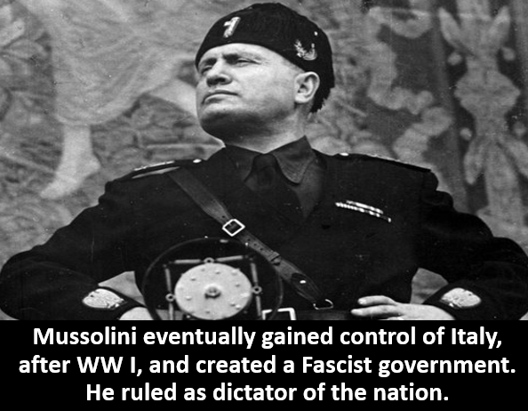A German veteran of WW I, Hitler felt that Germany was punished too harshly in the Treaty of Versailles. For instance, the treaty banned Germany from having an army. Through fascism, Hitler wanted to rise up against the treaty, regrow Germany’s military, and expand the nation through force. Likewise, Hitler wanted to grow the German economy thorough massive industrial plans to develop a modern military arsenal. He desired a result similar to FDR’s New Deal, to put Germans back to work. Yet, he craved to supercharge the German military through creating weapons factories, not just peaceful infrastructure.

Hitler’s fascist political party was called the National Socialist German Workers Party, the Nazi Party. This evil, radical party saw Arian, White Europeans of German descent as the master race. They were racist toward Jews and other minority groups. The policies of the Party were spelled out in Hitler’s book called *Mein Kampf* (My Struggle).

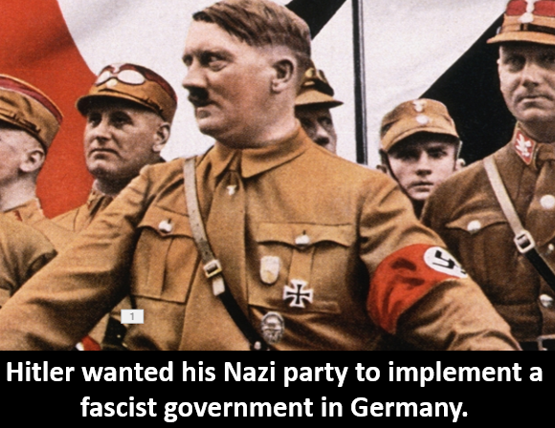Imprisoned for trying violently to overthrow the Weimer Republic, Hitler’s book became a manifesto for his fascist intentions for Germany. Though the Nazi’s attempt for power failed in 1923, their movement gained momentum, after Hitler was released from prison. Hitler claimed Germany would never economically revive unless it gained lebensraum, living space. This required military invasions of areas surrounding their country. In February of 1933, the Reichstag, where the Weimer Republic Parliament met, caught fire. Nobody knew who did it. The Nazi’s blamed Communist terrorists. Yet, many assumed the Nazi’s did it to take power.

In 1933, the Nazi’s gained power, removed the Weimer Republic, and established the Third Reich as the fascist government of Germany. Hitler’s SS (Schutzstaffel) soldiers murdered various individuals Hitler saw as rivals during the Night of the Long Knives, from June 30 to July 2nd of 1934. Another militant group in the Nazi Party, the Gestapo, also carried out horrific acts of violence. Hitler committed unspeakable evil, once he became the dictator of Germany. He persecuted minorities, like Jews, through creating concentration death camps to imprison and kill various groups. The Nazi’s took over all aspects of German life. Art, speech, and other expressions had to praise the Nazi agenda or face persecution. Anti-Semitism, racism toward Jews, was implemented as government policy through various forms of discrimination and violent oppression. Children had to join groups like the Hitler Youth, where they were brainwashed to offer supreme loyalty to Hitler. Books were burned that did not exalt the goals of the Nazi’s or stood opposed to them. Many people in Germany were simply conditioned to offer a cult like devotion to Hitler.

In Spain, a Civil War broke out killing hundreds of thousands of people. By 1939, with the help of Mussolini and Hitler, Francisco Franco (1892-1975) emerged as the fascist dictator of Spain and won the Spanish Civil War. In Japan, in the 1940s, though they had an emperor, Hirohito (1901-19899), Hideki Tojo (1884-1948) ruled as a dictator in the office of Prime Minister and was using his military to expand into various areas of Asia. Japan was not Fascist or Communist. Yet, they were totalitarian. In the 1920 and 1940s, Joseph Stalin (1878-1953) was ruling the Soviet Union (Russia) as the Communist dictator. Communism is different from Fascism in that it seeks to remove economic classes from society by claiming to allocate all resources equally. Fascism allows for private property. So, it is no Communism. As previously stated, both Fascism and Communism share this, they are totalitarian regimes. This means one person or small group has absolute control. As the world entered into the 1930s, it was evident that the world’s democracies, the USA, Britain, France, and others, were experiencing tension with the totalitarian dictatorships appearing in the world.

**Answers:**

**Part 1: Crossword Puzzle:**

Weimar The ____________ Republic lasted from 1918 to 1933.

Versailles The Treaty of __________________ of 1920 officially ended WW I.

Inflation ____________ is when money becomes weaker over time.

Hoover Herbert _________________was the Republican President of the USA, when the Great Depression began in 1929.

Deal FDR’s program actively to push back against the Great Depression was called the New _______________.

Mussolini Benito _______________ set up a fascist government in Italy.

Lebensraum Hitler claimed Germany would never economically revive unless it gained ___________________, living space.

Franco Francisco _________________ emerged as the fascist dictator of Spain.

Stalin In the 1920 and 1940s, Joseph ____________________ was ruling the Soviet Union as the Communist dictator.

**Part 2: Open Response:**

|  |  |  |  |
| --- | --- | --- | --- |
| 1. What was the purpose of the New Deal? Who created it? Why would some support it? Why would some oppose it?  *FDR’s program actively to push back against the Great Depression was called the New Deal. It practiced deficit spending, which is when the government has to spend more than it has through borrowing. This required increasing taxes too. Supporters of the New Deal felt it helped alleviate some of the immediate pain many experienced in the Great Depression, such as joblessness. Critics of the New Deal argued it increased taxes, grew America’s debt, and only created temporary jobs, not lasting careers. They felt FDR was given too much power and that some of his actions as president violated his constitutional authority.* | | |  |
|  | 2. Describe some dictators that rose up on the eve of World War II. What countries were they from? How did their rise impact the people they ruled over?  *In Spain, a Civil War broke out killing hundreds of thousands of people. By 1939, with the help of Mussolini, the Fascist dictator of Italy, and Hitler, the Fascists dictator of Germany, Francisco Franco emerged as the fascist dictator of Spain and won the Spanish Civil War. In Japan, in the 1940s, though they had an emperor, Hirohito, Hideki Tojo ruled as a dictator in the office of Prime Minister and was using his military to expand into various areas of Asia. Japan was not Fascist or Communist. Yet, they were totalitarian. In the 1920 and 1940s, Joseph Stalin was ruling the Soviet Union (Russia) as the Communist dictator. In all these scenarios, people lost rights and faced oppression from leaders with total control.* | | |
| 3. What economic problems did Germany face after World War I? How did the Weimer Republic try to address those problems? Were they successful?  *The Weimar Republic lasted from 1918 to 1933. This was a German democracy that faced many problems after WW I. The Treaty of Versailles of 1920 officially ended WW I. All nations were trying to rebuild. Yet, Germany was given a “war guilt clause.” This meant Germany was forced to pay for war damages to the Allies. This caused their already struggling economy to struggle even more. Germany attempted to print large amounts of money to pump into their economy to give people more cash to spend and pay off debts. Yet, this made their economy worse. Inflation is when money becomes weaker over time. Printing massive amounts of currency sped up inflation and made the German currency, called the mark, very weak. Something as simple as bread would cost roughly one mark before WW I. After Germany printed massive amounts of money, bread cost over one hundred marks.* | |  | |

**Do you need more resources?**

**We’ve got you covered with EVERYTHING you need to teach World History ALL YEAR!**

**Come check us out at TeachWorldHistory.com to get**

**FREE curated videos, worksheets, PowerPoints,**

**quizzes, and more!**

[**www.TeachWorldHistory.com**](http://www.TeachWorldHistory.com)