Black History
Month Bell Ringers

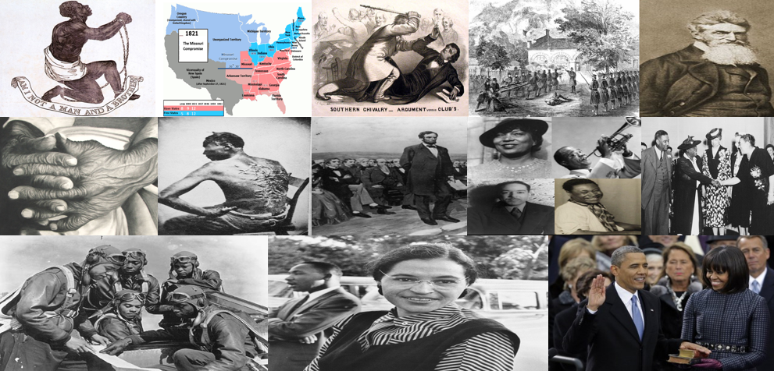

Table of Contents

P. 3-4 | Slavery Divides the Nation
P. 5-6 | The Missouri Compromise
P. 7-8 | Preston Brooks Attacks Charles Sumner
P. 9-10 | Frederick Douglas
P. 11-12 | Harriet Tubman and the Underground Railroad
P. 13-14 | John Brown
P. 15-16 | Images Concerning the Cruelty of Slavery
P. 17-18 | The Gettysburg Address
P. 19-20 | The Harlem Renaissance
P. 21-22 | Mary Bethune, Eleanor Roosevelt, and Civil Rights
P. 23-24 | The Tuskegee Airmen
P. 25-26 | Rosa Parks and Civil Rights
P. 27-28 | Abraham Lincoln, Martin Luther King Jr., and Barack Obama

Name:________________________________________________ Date:_____________ Class:____________

Slavery Divides the Nation
Instructions: Examine the picture, read the background description, and answer the questions below.

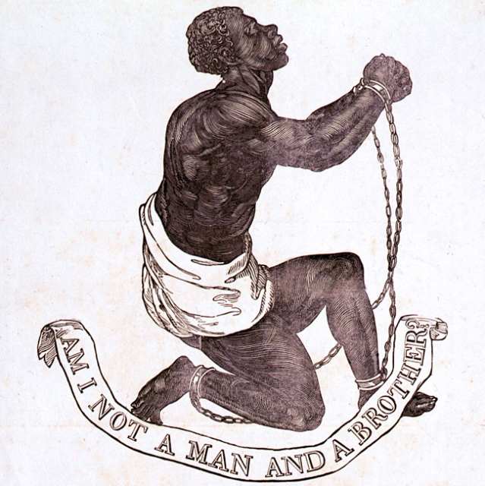
Description: In the Antebellum Era, the movement for abolitionism called for the abolishment of slavery. Many groups formed to protest the injustice of slavery. This symbol above was used by abolitionist groups to stress their desire to see slavery end. Many in the South justified the immoral use of slavery as necessary to maintain an agrarian, farming based economy.

1. What are some emotions that the artist who drew this wants you to feel when you view this picture?

2. Why do you think the artist included this quote in the picture, “Am I not a man and a brother?”

3. What is it about the Southern economy that made slavery so wide spread in this region of the USA during the Antebellum Era?
Answers:

1. What are some emotions that the artist who drew this wants you to feel when you view this picture?
Sadness, sympathy, empathy, compassion, concern, etc.

2. Why do you think the artist included this quote in the picture, “Am I not a man and a brother?”
The artists is trying to stress that mankind has a brotherhood that should transcend race. Simply because one has a different color of skin does not mean they should have to live a life trapped in awful slavery. All human beings deserve the same dignity.

3. What is it about the Southern economy that made slavery so wide spread in this region of the USA during the Antebellum Era?
The Southern economy was agrarian, which means it was based on agriculture. Cash cops like cotton began to dominate the region. This required a massive amount of human labor. The South justified the use of slaves to benefit their own economy.

Name:_________________________________________________ Date:_____________ Class:___________

Bell Ringer: The Missouri Compromise
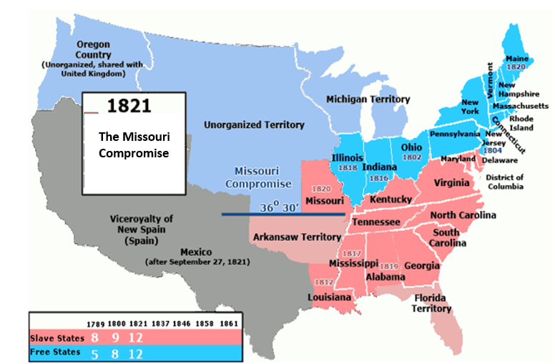
Instructions: Examine the map, read the background description below, and then answer the questions below.
Description: In the early 1800s, the North was heading towards industrialization as the South maintained an agrarian, farming based economy. Many in the South justified the immoral system of slavery as necessary for their agrarian economy. In relation to slavery, the Missouri Compromise came about in 1820. Missouri wanted to enter the Union as a slave state. Many in the North felt this would give too much power to the South in Congress. For a compromise, Maine was added as a free state to bring balance to the Legislative Branch, meaning the North and South would have similar influence in Congress. The compromise stated that all future states above 36’ 30’ would be free and states below this region could be slave states. Henry Clay of Kentucky had a significant role in the compromise.

1. In Congress, each state gets two Senators in the Senate and Representatives in the House of Representatives based on population. Why would this aspect of the USA government make the North and South cautious of a new territory becoming a state?

2. What was the Missouri Compromise? Explain.

Answers:
1. In Congress, each state gets two Senators in the Senate and Representatives in the House of Representatives based on population. Why would this aspect of the USA government make the North and South cautious of a new territory becoming a state?
For a compromise and to maintain a balance between Northern and Southern power in Congress, Maine was added as a free state and Missouri allowed to enter the union as a slave state. The North and South would have similar influence in Congress as a result. The compromise stated that all future states above 36’ 30’ would be free and states below this region could be slave states.

2. What was the Missouri Compromise? Explain.
In relation to slavery, the Missouri Compromise came about in 1820. Missouri wanted to enter the Union as a slave state. Many in the North felt this would give too much power to the South in Congress. For a compromise, Maine was added as a free state to bring balance to the Legislative Branch, meaning the North and South would have similar influence in Congress. The compromise stated that all future states above 36’ 30’ would be free and states below this region could be slave states. Henry Clay of Kentucky had a great role in the compromise.

Name:__________________________________________________ Date:____________ Class:___________

Bell Ringer: Preston Brooks Attacks Charles Sumner

Instructions: Read the background information below and examine the picture. Answer the questions.
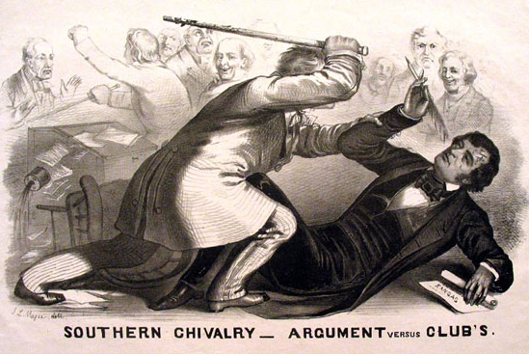
Background: In the mid-1800s, the USA was becoming drastically divided over the issue of slavery. Violence even broke out in Congress. A proslavery representative named Preston Brooks of South Carolina radically opposed the abolitionist movement. On May 22, 1956, Senator Charles Sumner of Massachusetts was delivering an anti-slavery speech in Washington D.C. in Congress. Preston Brooks attacked Charles Sumner with a cane for speaking against the South and slavery in the Senate chambers. This precursor displayed that the issue of slavery was becoming a violent, combative issue for the USA.

1. How does the artist want you to view Preston Brooks? How does this artist want you to view Charles Sumner? Explain your reasoning behind your answer.

2. Charles Sumner was from the North in Massachusetts and Preston Brooks was from the South in South Carolina. Why do you think many in the North were sympathetic to abolitionism and many in the South were for the continuation of slavery? Explain.

Answers:
1. How does the artist want you to view Preston Brooks? How does this artist want you to view Charles Sumner? Explain your reasoning behind your answer.
The artist appears to depict Preston Brooks as the aggressor. He even includes the title mocking the South that says, “SOUTHERN CHIVALRY-ARGUMENT versus CLUBS.” Therefore, the artist wants you to view Preston Brooks in a negative light. Charles Sumner looks defenseless and designing to use arguments over violence. Therefore, the artist wants you to view Charles Sumner in a positive light.

2. Charles Sumner was from the North in Massachusetts and Preston Brooks was from the South in South Carolina. Why do you think many in the North were sympathetic to abolitionism and many in the South were for the continuation of slavery? Explain.
The Northern economy was industrial based and not directly dependent on slavery. Though, they were indirectly dependent on Southern crops. The South used forced human labor in their agrarian economy. Therefore, their economy would radically change if slavery was removed. Partially due to these contrasting economic differences, the Northern citizens were more inclined to favor abolitionism, while many in the South rejected any attempt to free the slaves.

Name___________________________________________________ Date_____________ Class___________

Frederick Douglas
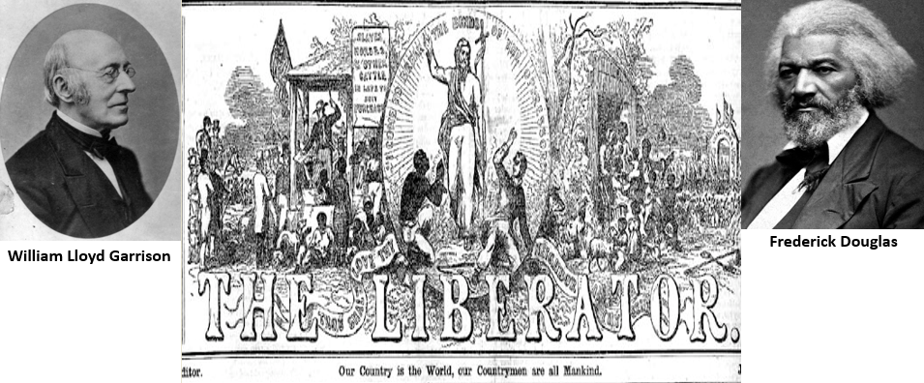
Instructions: Read the background information below and examine the picture. Answer the questions.
Background: Frederick Douglas (1818-1895) escaped slavery in Maryland and became an abolitionist. The abolitionists wanted to abolish slavery. Douglas was a prolific author and wrote against the injustices of slavery in the United States. Likewise, he traveled to various areas to give speeches against slavery. Douglas was heavily influenced by William Lloyd Garrison. Garrison started a news journal called The Liberator. The publication played a massive role in urging other Americans to embrace the abolitionist cause and resist the wrongs of slavery. Douglas also traveled to Great Britain to speak on issues of inequality and slavery in the USA. Douglas championed the rights of other groups as well. For instance, he consistently argued for full suffrage rights for all women. Suffrage means the right to vote. After his travels abroad, Douglas then started his own newspaper, The North Star, to advocate for abolitionism. During the Civil War, Douglas urged African Americans to serve as soldiers for the North. He was even able to gain an audience with Abraham Lincoln to petition for the Union to allow African American soldiers to serve. These efforts helped the North to allow African Americans to serve the Union during the Civil War. At the conclusion of the Civil War, after the passing of the 13th Amendment, which ended slavery, Douglas fought for equality for African Americans and equality for all people the rest of his life.

- How did Frederick Douglas have a unique perspective concerning the abolitionist movement?

- Describe the purpose of The Liberator and The North Star. Why would publications like these be important for the abolitionist movement?

- What concerns did Douglas advocate for throughout his life? Describe how he advocated for them.
Answers:
- How did Frederick Douglas have a unique perspective concerning the abolitionist movement?
Many people supported the abolitionist movement because it was ethically right to see slavery end. Yet, Douglas had actually been a slave himself. Therefore, he could not only appeal to the immorality of slavery, he could also appeal to person experience in asserting America must embrace abolitionism.

- Describe the purpose of The Liberator and The North Star. Why would publications like these be important for the abolitionist movement?
The Liberator and the North Star were publications advocating for abolitionism. In this 1800s, newspapers and news journals radically helped information to spread quickly. These publications were unifying mechanisms to help the abolitionists petition for the end of slavery.

- What concerns did Douglas advocate for throughout his life? Describe how he advocated for them.
Douglas consistently advocated for those mistreated in society through his speeches and writings. A major concern of his was to see slavery end, which is called abolitionism. Yet, he also fought for other groups too, such as calling for all women to gain the right to vote. Even after slavery ended, Douglas fought for equality for the rest of his life.

Name______________________________________________________ Date____________ Class_________
Harriet Tubman and the Underground Railroad
Instructions: Read the background information below and examine the picture. Answer the questions.
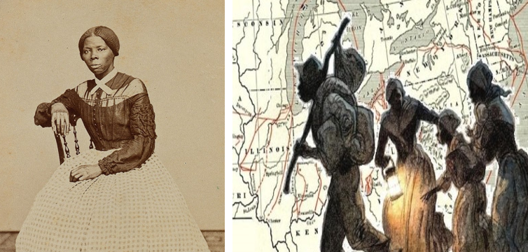
Background: Harriet Tubman (1822-1913) was born as a slave in Maryland. She experienced horrific physical abuse as a slave. She was once struck in the head by a slave owner. This trauma brought with it persistent symptoms, such as pain and dizziness, that lasted her entire life. In 1849, she courageously escaped to Pennsylvania and achieved her freedom. While this accomplishment was remarkable, she then returned multiple times to help other slaves escape, including friends and family. She was a “conductor” on the Underground Railroad. The Underground Railroad was a system in which people would allow escaped slaves to stay at various points as they traveled, typically at night, to areas in the North to achieve freedom. Even after the Fugitive Slave Act was passed, which allowed people to kidnap escaped slaves and return them to their so called owners in the South, Tubman bravely continued her work. When the Civil War started, Tubman served the Union Army as a cook and nurse. Likewise, she served gathering information for the Union as a spy. She was present in the Union’s raid on Combahee Ferry in South Carolina. This raid led to the liberation of hundreds of slaves.
- Describe Harriet Tubman’s life up until her escape to freedom.

- What was the Underground Railroad? What does it mean that Tubman was a “conductor” on the Underground Railroad?

- Why do you think Tubman felt compelled to risk so much, after she was free, by returning to help other slaves?

- Describe the impact Tubman had during the Civil War.
Answers:
- Describe Harriet Tubman’s life up until her escape to freedom.
Tubman experienced abuse often as a slave. She even had a head injury that left her with permanent symptoms.

- What was the Underground Railroad? What does it mean that Tubman was a “conductor” on the Underground Railroad?
The Underground Railroad was a system in which people would allow escape slaves to stay at various points as they traveled, typically at night, to areas in the North to achieve freedom. Since she led many to freedom on it, Tubman was considered a conductor.

- Why do you think Tubman felt compelled to risk so much, after she was free, by returning to help other slaves?
Tubman seemed to have a desire to see other freed too. She apparently had tremendous courage and profound empathy in this endeavor. She was no content with her own freedom, she wanted others freed too.

- Describe the impact Tubman had during the Civil War.
When the Civil War started, Tubman served the Union Army as a cook and nurse. Likewise, she served gathering information for the Union as a spy. She was present in the Union’s raid on Combahee Ferry in South Carolina. This raid led to the liberation of hundreds of slaves.

Name:______________________________________________ Date:______________ Class:_____________

Bell Ringer: John Brown

Instructions: Examine the picture. Read about the background information. Answer the questions below.
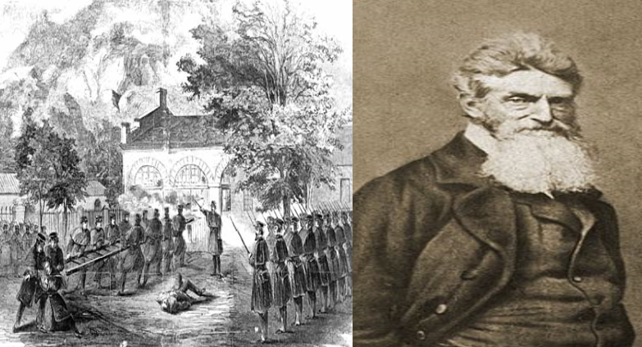
Background: In this era, the Compromise of 1850 and other issues seemed to insinuate that the political process was working in such a way that the North was actually cooperating, reluctantly, to not challenge slavery in the South. At Harper’s Ferry, a man named John Brown led a violent uprising in Virginia that was put down by the government. Brown felt he could take government weapons and create an uprising against slavery. However, his rebellion failed and he was executed. He was quoted as saying, “I, John Brown, am now quite certain that the crimes of this guilty land can never be purged away but with blood…” Events like John Brown’s raid, violence in Kansas over the issue of slavery, the attack on Charles Sumner by Preston Brooks in Congress, and other events were precursors to the Civil War. Pictured above is a depiction of the attempted revolt at Harper’s Ferry and a photo of John Brown.

1. Why do you think that John Brown thought slavery would only end through violence? Explain.

2. Explain how John Brown would be viewed by abolitionists and how Southern plantation owners would have viewed John Brown. Explain what their opinions of him would be.

3. How did events like John Brown’s attempted rebellion show that the USA was heading toward Civil War?
Answers:
1. Why do you think that John Brown thought slavery would only end through violence? Explain.
John Brown felt that the political process was not working to end slavery. The Compromise of 1850 even asserted the North was going to start enforcing the fugitive state slaw more strictly. Therefore, Brown had given up on political activity alone to end slavery and felt violence was needed.

2. Explain how John Brown would be viewed by abolitionists and how Southern plantation owners would have viewed John Brown. Explain what their opinions of him would be.
Many abolitionists would have been sympathetic by Brown, even if they felt his views were on the fringe and radical. Southern plantation owners would have detested Brown’s move and used it to assert that the abolitionist movement was radical and extremist.

3. How did events like John Brown’s attempted rebellion show that the USA was heading toward Civil War?
The frustration of the issue of slavery had turned violent. This was a foreshadowing of what was about to happen nationally. Violence had erupted in Kansas and even in Congress when Preston Brooks attacked Charles Sumner. These were precursors to the violence of the Civil War.

Name:______________________________________________ Date:_______________ Class:____________

Bell Ringer: Images Concerning the Cruelty of Slavery

Instructions: Look at the pictures, answer the questions below.
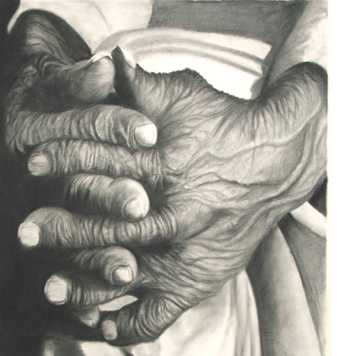
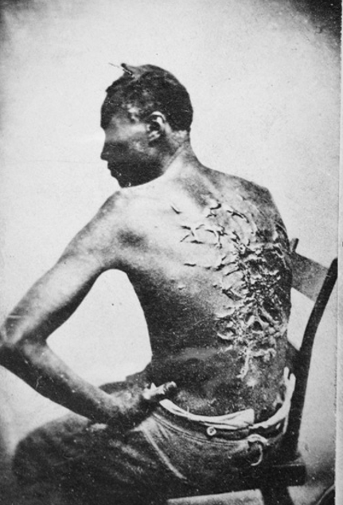

1. Look at the depiction of the hands. If you had to explain what this man’s life was like just by this depiction, what would you say? Explain.

2. Look at the picture of the man’s back with the terrible scars. What are four descriptions you would give to describe this picture?

3. Pictures like these show that human beings are capable of terrible evil. What steps could mankind take to prevent slavery, physical abuse, and other evils that have happened in history?

Answers:
1. Look at the picture of the hands. If you had to explain what this man’s life was like just by this photo, what would you say? Explain.
Student answers will vary. The point is that the students will be able to see, from the man’s hands, that his life was a difficult one of manual labor and inhumane treatment in slavery.

2. Look at the picture of the man’s back with the terrible scars. What are four descriptions you would give to describe this picture?
Some descriptions may include inhumane, horrific, terrible, awful, appalling, sad, etc.

3. Pictures like these show that human beings are capable of terrible evil. What steps could mankind take to prevent slavery, physical abuse, and other evils that have happened in history?
Students may mention that learning about history helps people to see mistakes in the past and learn not to repeat them. They may also mention that laws could be passed to prevent such abuses. People could also take time to learn about the importance of tolerance and respecting the rights of others.

Name:__________________________________________________ Date:____________ Class:___________

Bell Ringer: The Gettysburg Address
Instructions: Read the description. Read the excerpts. Answer the questions.

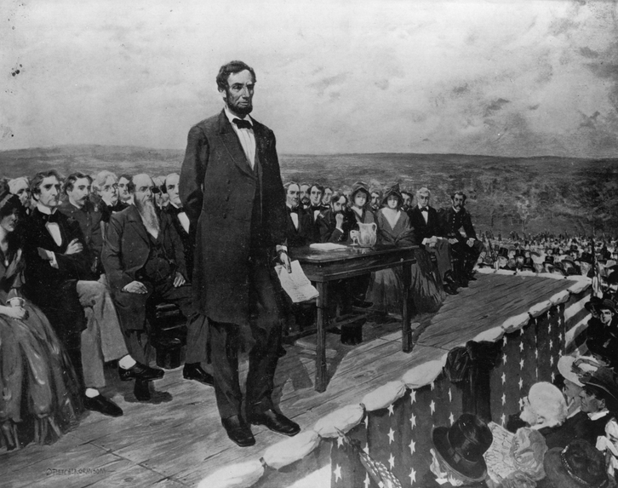
Background: After a major Battle in the Civil War, the Battle of Gettysburg, President Abraham Lincoln gave a speech to commemorate those who lost their lives. Lincoln felt the USA was founded on the assertion that all men were created equal. Yet, slavery of African Americans displayed we were not living up to that assertion. Read the excerpts below and answer the questions.

“We hold these truths to be self-evident, that all men are created equal, that they are endowed by their Creator with certain unalienable Rights, that among these are Life, Liberty and the pursuit of Happiness.--That to secure these rights, Governments are instituted among Men, deriving their just powers from the consent of the governed, --That whenever any Form of Government becomes destructive of these ends, it is the Right of the People to alter or to abolish it, and to institute new Government, laying its foundation on such principles and organizing its powers in such form, as to them shall seem most likely to effect their Safety and Happiness.”
-Thomas Jefferson, Excerpt from The Declaration of Independence, July 4th, 1776

“Four score and seven years ago our fathers brought forth on this continent, a new nation, conceived in Liberty, and dedicated to the proposition that all men are created equal. Now we are engaged in a great civil war, testing whether that nation, or any nation so conceived and so dedicated, can long endure. We are met on a great battle-field of that war. We have come to dedicate a portion of that field, as a final resting place for those who here gave their lives that that nation might live. It is altogether fitting and proper that we should do this. But, in a larger sense, we cannot dedicate -- we cannot consecrate -- we cannot hallow -- this ground. The brave men, living and dead, who struggled here, have consecrated it, far above our poor power to add or detract. The world will little note, nor long remember what we say here, but it can never forget what they did here.”
-Abraham Lincoln, Excerpt from The Gettysburg Address, November 19th, 1863

1. What similarities do you see between the words of Abraham Lincoln and that of Thomas Jefferson?
2. Why do you think Lincoln viewed the Civil War as a test concerning whether the USA could truly view all men as equal?
Answers:

1. What similarities do you see between the words of Abraham Lincoln and that of Thomas Jefferson?
Both reference the point that all people are created equal. Thomas Jefferson affirmed all people deserve life, liberty and the pursuit of happiness. Lincoln acknowledged this statement as an ongoing struggle to see if any nation can hold that view and put aside discrimination to pursue the goal of equality.

2. Why do you think Lincoln viewed the Civil War as a test concerning whether the USA could truly view all men as equal?
Lincoln was displaying that the idea that people are equal was present from the inception of the independence of the USA. He interprets the Civil War as a struggle to fully live up to that notion, that all people are created equal. He is referencing Jefferson to lend credibility to his assertion that these ideas of equality are as old as the nation itself. These words are being used to assert that slavery must end to live up to the desire of equality.

Name:______________________________________________ Date:_______________ Class:____________

The 1920s: The Harlem Renaissance
Instructions: Examine the pictures. Read the background information. Answer the questions.

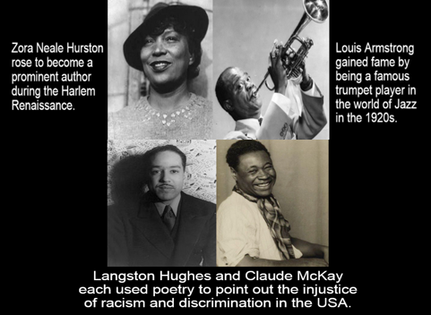

Background: During the Great Migration, from around 1916 to 1930, many African Americans fled the racism of the South and migrated North. Also, many businesses in the North were hiring African Americans, so there were more job opportunities. In the neighborhood of Harlem, in New York, a massive expression of African American culture and art resulted in the Harlem Renaissance. Poets, musicians, artists, and others contributed to the movement. Many artists used their fame to point out the injustice of racism in the USA. Pictured above are four artists that had a great impact on the Harlem Renaissance.

- What was the Great Migration and what caused the movement?

- What was the Harlem Renaissance and how did it impact the African Americans who had migrated to the North?
Answers:
- What was the Great Migration and what caused the movement?
During the Great Migration, from around 1916 to 1930, many African Americans fled the racism of the South and migrated North. Also, many businesses in the North were hiring African Americans, so there were more job opportunities.

- What was the Harlem Renaissance and how did it impact the African Americans who had migrated to the North?
In the neighborhood of Harlem, in New York, a massive expression of African American culture and art resulted in the Harlem Renaissance. Poets, musicians, artists, and others contributed to the movement. Many artists used their fame to point out the injustice of racism in the USA. Pictured above are four artists that had a great impact on the Harlem Renaissance.

Name:________________________________________________ Date:_____________ Class:____________
Mary Bethune
Instructions: Examine the picture. Read the background information. Answer the questions.
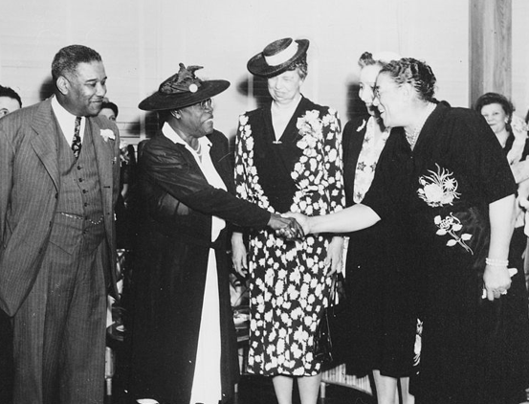
Background: Eleanor Roosevelt was FDR’s wife. She took a major role in supporting various political goals while FDR was President. Eleanor supported Civil Rights for African Americans as well. The struggle to give African Americans the rights they deserved grew in the 1930s. FDR appointed many African Americans to serve in government positions. Mary Bethune, an African American, was hired to serve in the National Youth Administration to help African American Youth. Bethune also served in FDR’s “Black Cabinet.” This group assisted FDR on issues dealing with minorities. While the Roosevelt administration saw some improvement with Civil Rights, many offered criticism as well. For instance, FDR refused to sign a federal anti-lynching law, saying it was a “states matter.” The New Deal programs that created jobs also discriminated against African Americans and even paid some workers less than whites. Pictured above is Eleanor Roosevelt standing beside Mary Bethune
1. How did Eleanor Roosevelt impact FDR’s administration?

2. Who was Mary Bethune and what role did she have FDR’s administration?

3. In what ways did FDR’s administration help advance Civil Rights for African Americans?

4. Despite some gains for Civil Rights being achieved in FDR’s administration, many still offered criticism for the way African Americans were treated while FDR was president. What were some of these criticisms?

Answers:
1. How did Eleanor Roosevelt impact FDR’s administration?
Eleanor Roosevelt was FDR’s wife. She took a major role in supporting various political goals while FDR was President. Eleanor supported Civil Rights for African Americans as well.

2. Who was Mary Bethune and what role did she have FDR’s administration?
Mary Bethune, an African American, was hired to serve in the National Youth Administration to help African American Youth. Bethune also helped create the “Black Cabinet.” This group assisted FDR on issues dealing with minorities.

3. In what ways did FDR’s administration help advance Civil Rights for African Americans?
FDR appointed many African Americans to serve in government positions. FDR also create the “Black Cabinet.” This group assisted FDR on issues dealing with minorities.

4. Despite some gains for Civil Rights being achieved in FDR’s administration, many still offered criticism for the way African Americans were treated while FDR was president. What were some of these criticisms?
While the Roosevelt administration saw some improvement with Civil Rights, many offered criticism as well. For instance, FDR refused to sign a federal anti-lynching law, saying it was a “states matter.” The New Deal programs that created jobs also discriminated against African Americans and even paid some workers less than whites.

Name:_____________________________________________ Date:________________ Class:____________
The Tuskegee Airmen

Instructions: Examine the picture. Read the background information. Answer the questions.
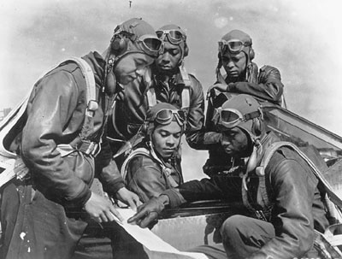
Background: In the 1940s, the United States practiced discrimination and segregation toward African Americans. This meant that African Americans had to use restrooms, schools, restaurants, and other facilities that were separated from white Americans. This unjust system caused many African American leaders to be concerned about African Americans who risked their very lives to protect a nation that did not provide them with true dignity and justice. Despite America’s legal discrimination, many African Americans served bravely to defend the nation in World War II. The Tuskegee Airmen were the nation’s first African American military pilots. The 99th Pursuit Squadron of the Tuskegee Airmen played a significant role in taking Sicily and invading Benito Mussolini’s Italy in World War II. Once in Italy, the Tuskegee Airmen fought against the German Luftwaffe, the aerial branch of the German military. When World War II ended, many Civil Rights leaders pointed back to the brave sacrifice of many African Americans to assert that segregation must end and all Americans, regardless of race, must be treated with equality.

1. Why were many African American leaders concerned about African American soldiers serving in World War II?

2. Who were the Tuskegee Airmen? What contribution did they have in World War II?

3. How did the brave service of African Americans in World War II impact the Civil Rights movement when the war ended?

Answers:
1. Why were many African American leaders concerned about African American soldiers serving in World War II?
The unjust system of discrimination and segregation in the USA caused many African American leaders to be concerned about African Americans who risked their very lives to protect a nation that did not provide them with true dignity and justice.

2. Who were the Tuskegee Airmen? What contribution did they have in World War II?
The Tuskegee Airmen were the nation’s first African American military pilots. The 99th Pursuit Squadron of the Tuskegee Airmen played a significant role in taking Sicily and invading Benito Mussolini’s Italy in World War II.

3. How did the brave service of African Americans in World War II impact the Civil Rights movement when the war ended?
When World War II ended, many Civil Rights leaders pointed back to the brave sacrifice of many African Americans to assert that segregation must end and all Americans, regardless of race, must be treated with equality.

Name:______________________________________________ Date:_______________ Class:____________
Rosa Parks

Instructions: Examine the picture and read the background information. Answer the questions.
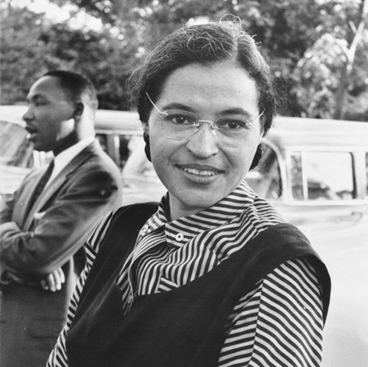
Background: In 1955, in Montgomery, Alabama, Rosa Parks, an African American woman, refused to obey the bus driver’s order that she give up her seat in the colored section to a white passenger, after the white section was filled. Parks was using peaceful civil disobedience to protest against the unjust segregation laws in Alabama. Parks' resistance became a vital symbol for the Civil Rights Movement. Civil Rights advocate and pastor, Dr. Martin Luther King Jr., helped to organize a boycott of the bussing system in Montgomery to stand against the injustice of segregation. This meant that all who supported Parks were called upon to stop using the bussing system and to cease spending money to ride the busses. King insisted that all who opposed segregation must do so peacefully and practice nonviolence. In 1956, partially due to the efforts of King and Parks, the bussing system in Montgomery was fully integrated and no longer segregated. Pictured above you see Rosa Parks and Dr. Martin Luther King Jr.

1. How did Rosa Parks impact the Civil Rights movement?

2. What role did Dr. Martin Luther King Jr. have in responding to the way Rosa Parks was treated in Montgomery?

3. Why do you think that Dr. Martin Luther King Jr. insisted that protests against segregation must be rooted in a nonviolent approach?
Answers:
1. How did Rosa Parks impact the Civil Rights movement?
In 1955, in Montgomery, Alabama, Rosa Parks, an African American woman, refused to obey the bus driver’s order that she give up her seat in the colored section to a white passenger, after the white section was filled. Parks was using peaceful civil disobedience to protest against the unjust segregation laws in Alabama. Parks' act of defiance became a vital symbol for the Civil Rights Movement.

2. What role did Dr. Martin Luther King Jr. have in responding to the way Rosa Parks was treated in Montgomery?
Civil Rights advocate and pastor, Dr. Martin Luther King Jr., helped to organize a boycott of the bussing system in Montgomery to stand against the injustice of segregation. This meant that all who supported Parks were called upon to stop using the bussing system and to cease spending money to ride the bus. King insisted that all who opposed segregation must do so peacefully and practice nonviolence.

3. Why do you think that Dr. Martin Luther King Jr. insisted that protests against segregation must be rooted in a nonviolent approach?
Student answers may vary. Dr. Martin Luther King Jr. was trying to stress that segregation and racial discrimination were immoral. Therefore, the tactics used to protest the injustice of segregation must by moral tactics. King and others were using this approach to prove that the Civil Rights Movement was on the right side of morality and that segregation was unjust and wicked.

Name:______________________________________________ Date:_______________ Class:____________
Obama, Lincoln, & King
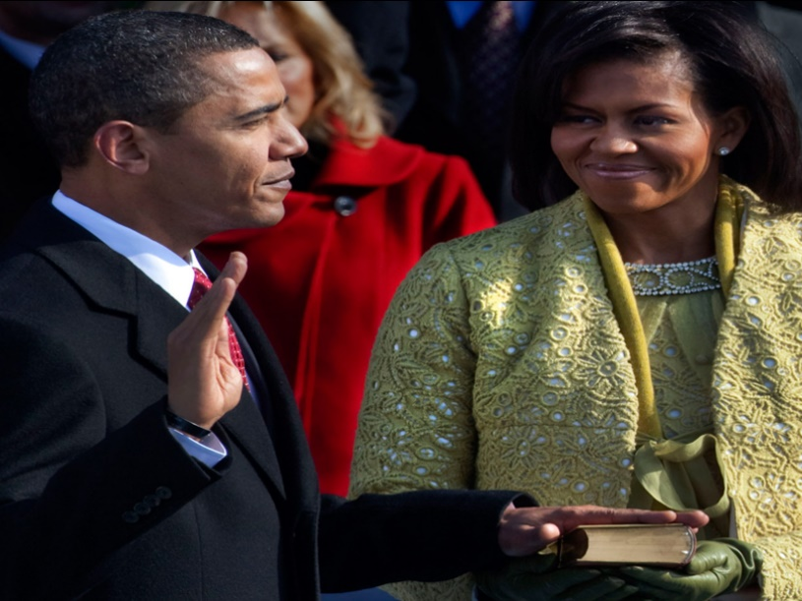
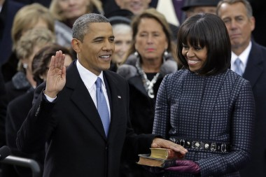
Instructions: Examine the pictures. Read the background information. Answer the questions.
Background: The history of the United States tragically included slavery of people from Africa and their descendants. During the Civil War, President Lincoln issued the Emancipation Proclamation, freeing the slaves in the South. Afterward, Congress freed all slaves by passing the 13th Amendment to the Constitution. Segregation and racism persisted in the United States into the 20th Century. In landmark decisions, such as Brown vs. Board of Education, the Supreme Court rejected the notions of segregation to ensure African Americans had equal protection in the United States. In 1964, thanks to the protest efforts of great men, like Dr. Martin Luther King Jr., Congress passed the Civil Rights Act that outlawed discrimination based on race, color, religion, sex, or national origin. It banned racial segregation in schools, at the workplace, and public facilities. In 2008, the United States elected the first African American President, Barack Obama. Traditionally, many Presidents used Bibles for their swearing in ceremonies. In 2009, Barack Obama used the former Bible of Abraham Lincoln for his swearing in ceremony. When he was reelected in 2012, he used the Bible of Lincoln again, along with a Bible of Dr. Martin Luther King Jr. These symbolic gestures acknowledged the impact of Lincoln and King in America’s struggle to give equal rights to all citizens. Pictured to the left, Obama is sworn in with Lincoln’s Bible in 2009. Pictured to the right, Obama is sworn in with Lincoln’s Bible and a Bible of Dr. Martin Luther King Jr. as well, in 2013.

1. How did Abraham Lincoln and Martin Luther King Jr. impact the rights of African Americans in the USA?

2. What was the 13th Amendment?

3. What was Barack Obama communicating by using the Bibles of Abraham Lincoln and Dr. Martin Luther King Jr. in his swearing in ceremonies? Explain.
Answers:
1. How did Abraham Lincoln and Martin Luther King Jr. impact the rights of African Americans in the USA?
President Lincoln issued the Emancipation Proclamation, freeing the slaves in the South. In 1964, thanks to the protest efforts of great men, like Dr. Martin Luther King Jr., Congress passed the Civil Rights Act that outlawed discrimination based on race, color, religion, sex, or national origin. It banned racial segregation in schools, at the workplace, and public facilities.

2. What was the 13th Amendment?
Congress freed all slaves by passing the 13th Amendment to the Constitution

3. What was Barack Obama communicating by using the Bibles of Abraham Lincoln and Dr. Martin Luther King Jr. in his swearing in ceremonies? Explain.
In 2009, Barack Obama used the former Bible of Abraham Lincoln for his swearing in ceremony. When he was reelected in 2012, he used the Bible of Lincoln again, along with a Bible of Dr. Martin Luther King Jr. These symbolic gestures acknowledged the impact of Lincoln and King in America’s struggle to give equal rights to all citizens.

Do you need more resources?
We’ve got you covered with all you will need to teach World History from 1200 CE to today’s
modern era!
Come visit us at
www.TeachWorldHistory.com

